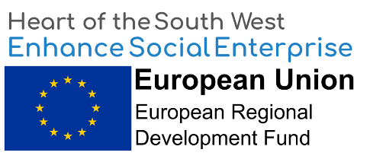

About Iridescent Ideas CIC

Iridescent Ideas CIC is an award winning social enterprise and Community Interest Company founded in Plymouth in 2011. Our mission is to provide business services that enable other ethical organizations to achieve their aims and objectives. For more about us please go to www.iridescentideas.com.

Summary of the project

The EU is funding Iridescent Ideas CIC to deliver business advice to existing social enterprises and start-ups in Devon and Somerset. The programme is called Enhance Social Enterprise. More information about Enhance can be found here…

We want to commission a freelance business adviser to help deliver this project with us.

Budget

£5,400 for 135 hours of work. We will pay £40 an hour. This figure includes VAT and any travel costs. The contract will run November 2019 to July 2020.

Objectives

- Delivering 12 hours of business advice to 10 social enterprises:
  - 6 social enterprises in Devon, Torbay or Plymouth
  - 4 social enterprises in Somerset

Broad themes of the advice are:

- Choosing an appropriate legal structure
- Support on governance
- Advice on social impact
- Advice on general business planning.

Advice can be delivered in person, over the telephone, via email or via Skype-type system.

How to quote

Please can you email us a short quotation to deliver this work setting out your experience in relation to this brief on no more than two sides of A4. Please send the quote to Gareth Hart (gareth@iridescentideas.com) by 5pm on 1st November 2019.

Please contact Gareth Hart by email: gareth@iridescentideas.com to talk about the work or if you have any questions.

